1.MapReduce TaskAttemptContext

Error :- Found interface org.apache.hadoop.mapreduce.TaskAttemptContext, but class was expected

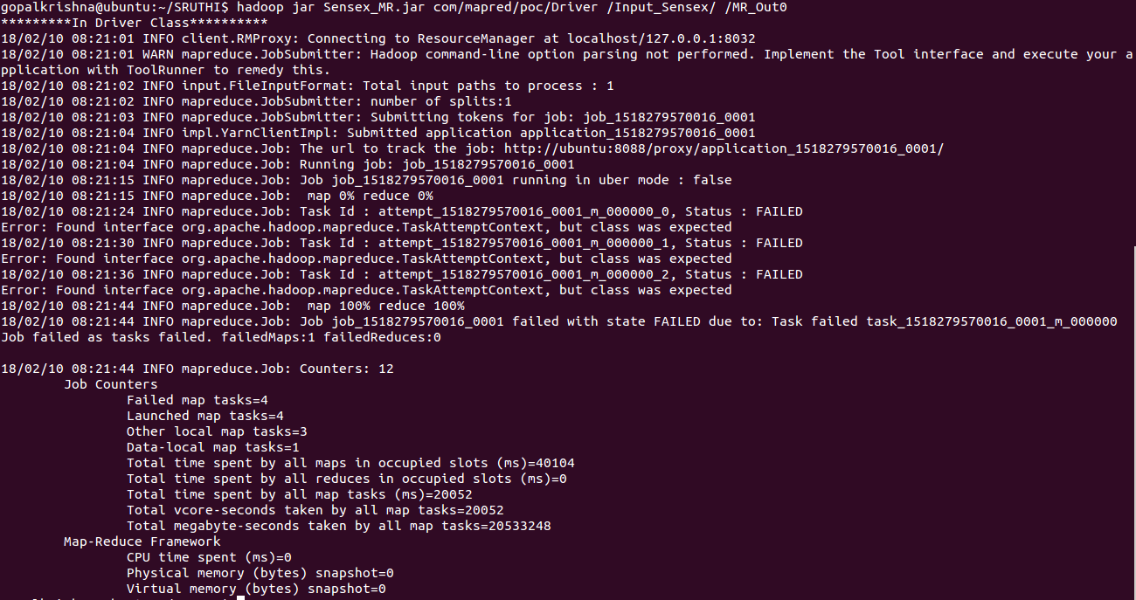

Description :- In MapReduce job, After the jar file creation without any errors and warnings.
While running the mapreduce job with corresponding jar fie. We got the error like
INFO mapreduce.Job: Task Id : attempt_1518279570016_0001_m_000000_0
Status:FAILED.
Error: Found interface org.apache.hadoop.mapreduce.TaskAttemptContext, but class was expected

Rectification:- In Hadoop 1.x version, org.apache.hadoop.mapreduce.TaskAttemptContext was a class but, In Hadoop 2.x it will became an Interface.
Based on this we need to Configure separately compiled jarfiles for Hadoop 1.x and Hadoop 2.x. So, In our UserStory we will configure the External jar files related to Hadoop 2.x like
hadoop-common-2.6.0.jar
hadoop-mapreduce-client-core-2.6.0.jar
hadoop-hdfs-2.6.0.jar
hadoop-client-2.6.0.jar

2. Mapreduce Input Header Error :-

Error:- Input file '.xlsx' file contains header.

Description :- To avoid the corresponding header we must have to write a code while reading the input file.

Rectification:- Additional code related to avoid the header of the Input file.

